Asia-China-Coin-Song- Money Plates

錢牌Qián pái (Money Plates).

These items are attributed the late Southern Song Dynasty, perhaps the Jing Ding period (1260-64). A contemporary source says:“The court ministries produced lead tablets for conven­ience of use in Hangzhou city because coins were not circulating". Clearly, they were a desperate emergency measure. Lead and bronze specimens are known; the top of the tally can be square， rounded， or with cut-off corners. The省*sheng* (reduced) in their inscription refers切 the Song“reduced hundred" system， whereby a nominal hundred cash was discounted by some 30 percent. Thus in the market place 100 cash was in fact equivalent to 77 for official use， 75 for general trading，72 for fish，meat，and vegetables，74 for gold and silver，68 for gems, fans, slave girls and crickets and 56 for writings - each sort of commodity had its own discount to the hundred.

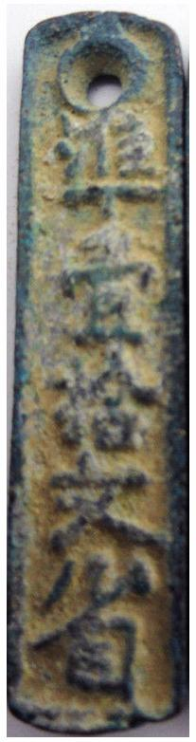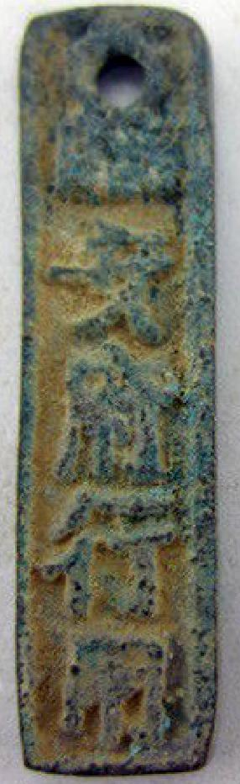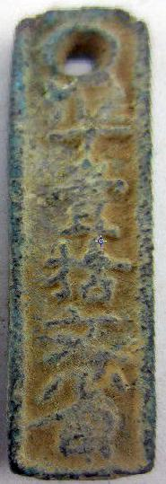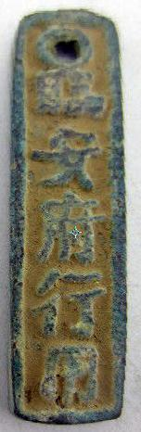

H 17.900 R2 size : 0.4 in. x 1.7 in. 15 gm

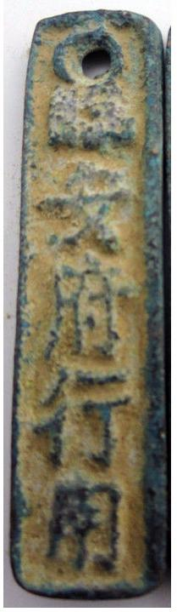

H 17.901 R 2, length1.6in., width 0.4 in., 14 gm.

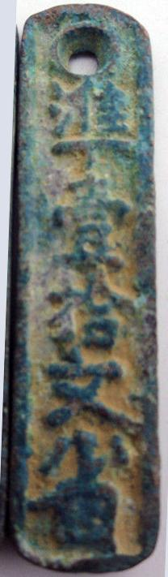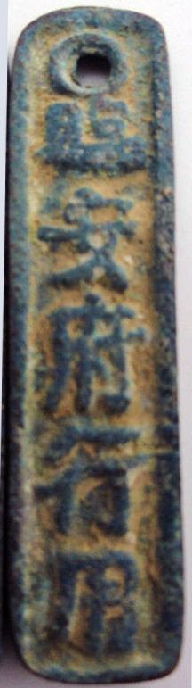

H 17.902 R 2, length1.6in., width 0.4 in., 14 gm.

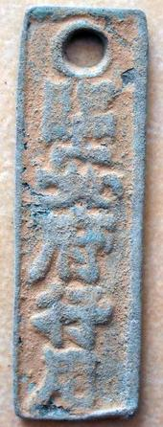 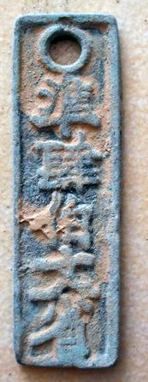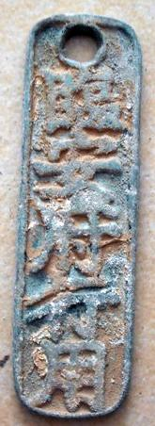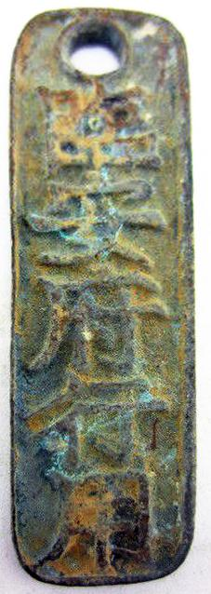

H 17.903 R 1, Height 6.2 cm.

H 17.903-4 Obv:臨安府行用 Lin An Fu Xing Yong. ([For] Lin An Prefecture use). Rev:海(准)貳佰文省*Zhun er b*αiω*en sheng* (Equal to 200 cash reduced). FD1600-1， S1064a

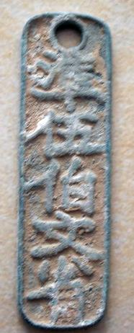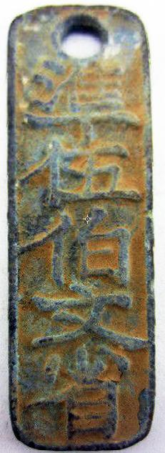

H 17.907 R0, Height 7.1 cm. Right: 1 in. x 3 in. 23 gm

17.907-8 Rev:單(准)伍佰文省Zhun wu bai wen sheng (Equal to 500 cash reduced). Ref.: FD 1605， S1064 R 0 Lin An (present-day Hangzhou in Zhejiang) was the capital of the Southern Song .obv (top:和州行用品 He Zhou Xing Yong ([For] He prefecture use.

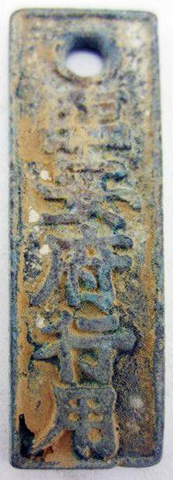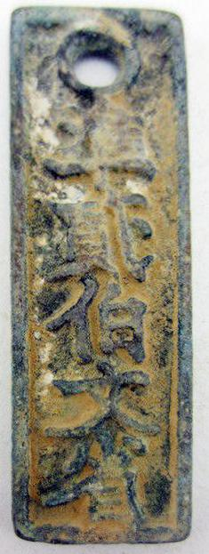

H 17.908 R 0. 0.8 in. x 2.5 in.

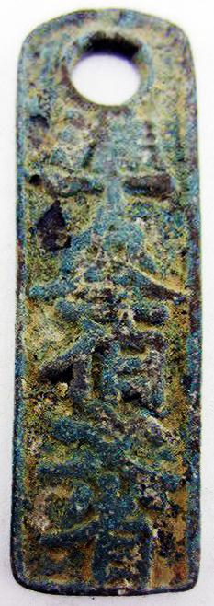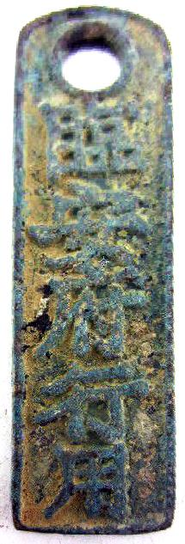

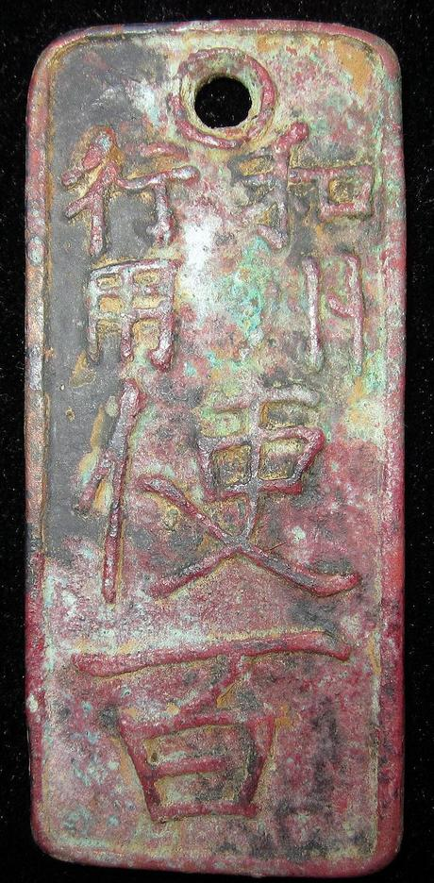 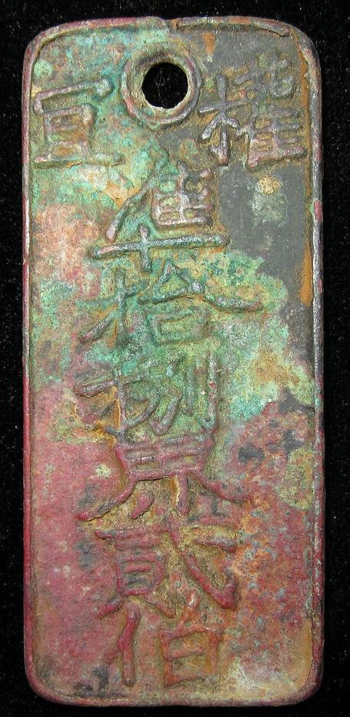

obv. 和州行用Hé zhōu xíng yòng ([For use within] He State Lines). 使百*Shi bai([This tally]* makes [is equivalent to] one hundred), rev. 權宣準拾捌界貳佰Quán Xuān Zhǔn shibā jiè èr bǎi, "Authority to declare standard value of eight Jiè [equivalent to] two Bai," i.e. equivalent to 200. This declaration of a currency standard indicates that eight Jiè are equivalent to "two Bai" or 200, so that four Jiè are equivalent to 100, which is the value of this Qian Pai. Jiè means "circle" which may refer to a traditional currency of perhaps a circular string of cowry shells or some other commodity that was arranged in a circular manner.

Very rare South Song Dynasty, Coin Tally which was used in 1240AD. Obv. 和州行用使百钱 " Tallies with state money to make one hundred". Rev. 准拾捌界贰佰. Which means that, 拾捌界贰佰 could be used as 100 basic coin in that period. H 17.910 R 2

H 17.909 obv. below十文百Shí wén bǎi ("Ten Wen Bai," i.e., 10 pieces [equivalent to] 100).

Order details Printer friendly page

Sold by

[bcculture](http://myworld.ebay.com/bcculture) ( [81](http://feedback.ebay.com/ws/eBayISAPI.dll?ViewFeedback&userid=bcculture)  )

+ Show additional actions

Delivery package 1 of 1

Estimated delivery Tuesday, Jan 21, 2014 - Tuesday, Feb 18, 2014

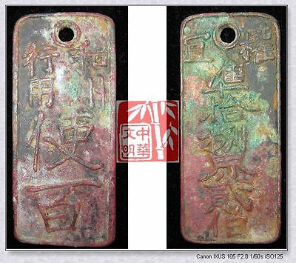

[ANTIQUE SOUTH SONG KINGDOM CURRENCY ￥100MONEY BRONZE COIN TOKEN CARD和州行用使百钱1240](http://www.ebay.com/itm/251395909770)

Item price

$49.99

Quantity

1

Item number

251395909770

Shipping service

Economy Shipping from outside US

[Leave feedback](http://feedback.ebay.com/ws/eBayISAPI.dll?LeaveFeedbackShow&useridfrom=802-867&useridto=bcculture&item=251395909770&transactid=1360749516015) [Contact seller](http://contact.ebay.com/ws/eBayISAPI.dll?FindAnswers&frm=3998&iid=251395909770&redirect=0&requested=bcculture) [Return item](http://return.ebay.com/ws/eBayISAPI.dll?ResolveReturn&eventName=viewSelectedItem&TransactionId=1360749516015&ItemId=251395909770)

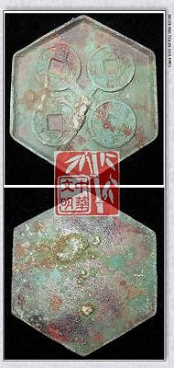

[SOUTH NORTH DYNASTY CHEN POLICY LAST MONEY MODEL BRONZE COIN PATTERN太货六铢钱范3"RARE](http://www.ebay.com/itm/251413172236)

Item price

$59.99

Quantity

1

Item number

251413172236

Shipping service

Economy Shipping from outside US

[Leave feedback](http://feedback.ebay.com/ws/eBayISAPI.dll?LeaveFeedbackShow&useridfrom=802-867&useridto=bcculture&item=251413172236&transactid=1360816867015) [Contact seller](http://contact.ebay.com/ws/eBayISAPI.dll?FindAnswers&frm=3998&iid=251413172236&redirect=0&requested=bcculture) [Return item](http://return.ebay.com/ws/eBayISAPI.dll?ResolveReturn&eventName=viewSelectedItem&TransactionId=1360816867015&ItemId=251413172236)

### Shipping address

Ralph J Coffman Jr  
149 Atlantic Ave   
Swampscott MA 01907-2427  
United States

Phone number  
781 584 7091

### Order total

Subtotal $109.98

Shipping $50.00

Shipping discount -$3.00

#### Total

## $156.98

[View PayPal transaction](http://payments.ebay.com/ws1/eBayISAPI.dll?IntermediateResolutionInfo&itemid=0&transId=0&pn=UnifiedCheckoutSummaryRedirect2PP&qs=itemid%3D0%26transId%3D0%26buyerorseller%3D0%26)

### Order information

Order placed on  
Monday, Dec 30, 2013

Having a problem with this purchase?  
[Resolve problem](http://res.ebay.com/ws/eBayISAPI.dll?ResolutionCenter)

Payment method   
PayPal

Payment date  
Monday, Dec 30, 2013

|  |
| --- |
|  |
| [Ad Feedback](javascript:void(0);)|[AdChoice **- opens in a new window or tab**](javascript:void(0);) |